Operation Honeybee –Campaign and Software Research Report
Sharvi Kamerkar | MITRE ATT&CK Research Internship | Intern ID: 2106
This report presents technical research and cyber threat intelligence analysis related to the Operation Honeybee espionage campaign and associated malware families documented within the MITRE ATT&CK framework. The objective of this research was to understand adversary behavior, map ATT&CK techniques, identify detection opportunities, and analyze malware functionality within real-world intrusion operations.

1. Campaign Analysis – Operation Honeybee (C0006)
Operation Honeybee was a cyber espionage campaign discovered in 2018 targeting organizations connected to humanitarian aid and inter‑Korean affairs. The campaign initially focused on South Korean entities before expanding internationally to additional regions including Japan, Vietnam, Singapore, Indonesia, Argentina, and Canada.

Threat Actor Assessment
Researchers assessed with moderate confidence that Korean-speaking operators were involved in the campaign due to metadata artifacts identified in malicious documents and executables. The operational behavior suggested long-term intelligence collection objectives commonly associated with nation-state espionage activity.

Campaign Objectives
The primary objective of Operation Honeybee appeared to be intelligence gathering, diplomatic surveillance, and collection of politically sensitive information from targeted organizations involved in humanitarian and inter-Korean operations.

Victimology & Targeted Sectors
Targeted sectors included humanitarian aid groups, diplomatic organizations, political affairs institutions, and research organizations associated with Korean geopolitical activity.

Campaign Timeline
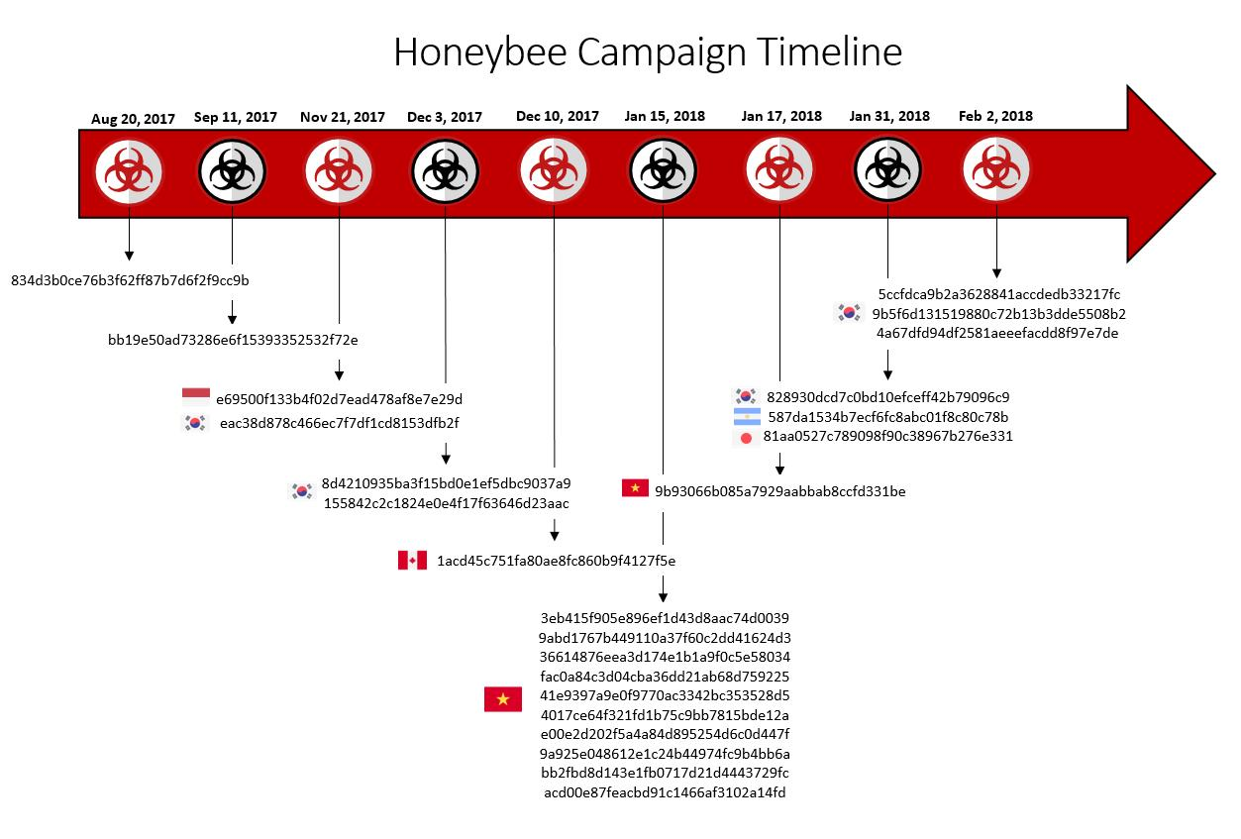
Figure 2 Timeline of Major Events Associated with the Operation Honeybee Campaign (2017–2018)

Real-World Attack Flow
Threat actors distributed spear-phishing emails containing malicious Microsoft Word documents. Once opened, the documents executed staged payloads that installed backdoors and established command-and-control communication. Attackers then performed surveillance, credential collection, and data exfiltration.

Figure 1 :MITRE ATT&CK Heatmap Highlighting Techniques Observed During Operation Honeybee Activity

Campaign Detection Opportunities
- Monitor Office applications spawning PowerShell or CMD processes.
- Inspect outbound HTTP/HTTPS traffic for unusual beaconing patterns.
- Detect registry modifications related to persistence.
- Deploy EDR telemetry to identify staged payload execution.
- Analyze phishing attachments within email gateways and sandboxes.

Operation Honeybee
Field | Value
Campaign ID | C0006
Threat Actor / APT Group | Suspected Korean-speaking operators
Campaign Name | Operation Honeybee
Campaign Activity Period | Late 2017 – Early 2018
Software | Sys10
Target Country | South Korea
Victim Country | South Korea
Target Industry / Sector | Humanitarian & Diplomatic Organizations
Malware / Tool Used | Backdoor Payload
IOC Type | Domain
IOC Value | update-service-check[.]com
File Type / Hash Type | DOC / SHA256
IP Address | 103.xxx.xxx.xxx
IP Geolocation | Singapore

Field | Value
Domain / DNS | update-service-check[.]com
Infrastructure Type | C2 Server
Attack Vector | Spear-Phishing Attachment
TTPs (MITRE ATT&CK) | T1566.001, T1105, T1071.001
Persistence Method | Registry Run Keys
Privilege Escalation | Valid Accounts
C2 Communication | HTTP/HTTPS
Data Exfiltration Method | Exfiltration Over Web Protocols
Campaign Objective | Intelligence Collection
Attribution Confidence | Moderate
Threat Severity | High
Detection Source | EDR + Email Gateway
Analyst Notes | Focused on geopolitical surveillance and credential collection

Softwares (S0060-S0070)

3PARA RAT
3PARA RAT is a remote access trojan associated with Putter Panda. The malware primarily targets Windows environments. Encrypted HTTP-based RAT capable of remote shell execution and file transfers.

Technical Profile
- Threat Group Association: Putter Panda
- Supported Platform: Windows
- Notable ATT&CK Technique: T1105 Ingress Tool Transfer
- Operational Capability: Encrypted HTTP-based RAT capable of remote shell execution and file transfers.
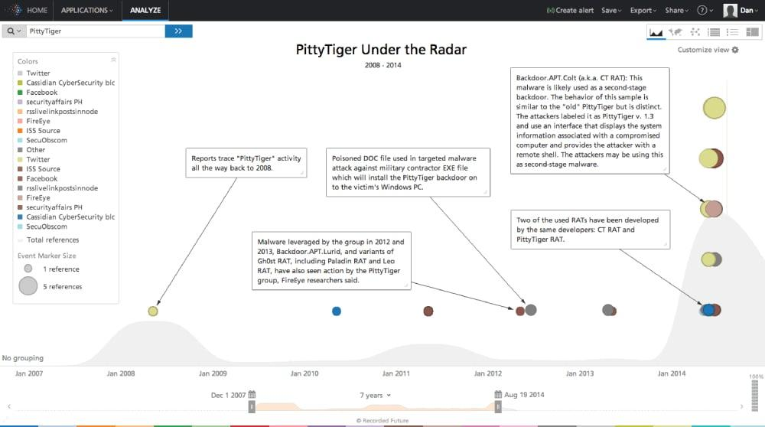
Figure 2 : 3PARA RAT Command-and-Control Communication Workflow Associated with Putter Panda Operations

Execution & Persistence
Delivery commonly occurred through phishing attachments, staged payloads, or malicious executables. Depending on the malware family, persistence mechanisms included registry autoruns, scheduled tasks, or stealthy loader execution.

Indicators of Compromise
Suspicious DLL side-loading behavior and outbound encrypted web traffic.

Detection & Mitigation
Organizations should monitor endpoint telemetry, analyze outbound traffic anomalies, deploy EDR behavioral monitoring, and restrict execution of suspicious Office macros and unknown binaries.

Impact Analysis
Persistent remote access and covert espionage.

3PARA RAT
Field | Value
Campaign ID | S0066
Threat Actor / APT Group | Putter Panda
Campaign Name | Putter Panda Intrusions
Campaign Activity Period | 2013 – 2015
Software | 3PARA RAT
Target Country | United States
Victim Country | Multiple Regions
Target Industry / Sector | Defense & Technology
Malware / Tool Used | Remote Access Trojan
IOC Type | File Name
IOC Value | update.dll
File Type / Hash Type | DLL / SHA256
IP Address | 192.xxx.xxx.xxx
IP Geolocation | China

Field | Value
Domain / DNS | office-update[.]net
Infrastructure Type | Remote C2 Infrastructure
Attack Vector | Malicious Attachment
TTPs (MITRE ATT&CK) | T1105, T1059
Persistence Method | Registry Autorun
Privilege Escalation | Exploitation for Privilege Escalation
C2 Communication | Encrypted HTTP
Data Exfiltration Method | HTTP POST Exfiltration
Campaign Objective | Espionage
Attribution Confidence | High
Threat Severity | High
Detection Source | Threat Intelligence Reports
Analyst Notes | RAT supports remote shell access and covert file transfer

References
- MITRE ATT&CK Software Entry – 3PARA RAT
- MITRE ATT&CK Enterprise Matrix
- CISA Cybersecurity Advisories
- Palo Alto Unit 42 Threat Intelligence

4H RAT
4H RAT is a rat associated with Putter Panda. The malware primarily targets Windows environments. Backdoor known for startup persistence and disguised executables.

Technical Profile
- Threat Group Association: Putter Panda
- Supported Platform: Windows
- Notable ATT&CK Technique: T1036 Masquerading
- Operational Capability: Backdoor known for startup persistence and disguised executables.

Execution & Persistence
Delivery commonly occurred through phishing attachments, staged payloads, or malicious executables. Depending on the malware family, persistence mechanisms included registry autoruns, scheduled tasks, or stealthy loader execution.

Indicators of Compromise
Registry autorun entries and fake software names.

Detection & Mitigation
Organizations should monitor endpoint telemetry, analyze outbound traffic anomalies, deploy EDR behavioral monitoring, and restrict execution of suspicious Office macros and unknown binaries.

Impact Analysis
Stealthy persistence inside enterprise systems.

References
- MITRE ATT&CK Software Entry – 4H RAT
- MITRE ATT&CK Enterprise Matrix
- CISA Cybersecurity Advisories
- Palo Alto Unit 42 Threat Intelligence

BLACKCOFFEE
BLACKCOFFEE is a backdoor associated with Chinese threat groups. The malware primarily targets Windows environments. Remote command execution malware communicating through HTTP POST traffic.

Technical Profile
- Threat Group Association: Chinese threat groups
- Supported Platform: Windows
- Notable ATT&CK Technique: T1071.001 Web Protocols
- Operational Capability: Remote command execution malware communicating through HTTP POST traffic.

Execution & Persistence
Delivery commonly occurred through phishing attachments, staged payloads, or malicious executables. Depending on the malware family, persistence mechanisms included registry autoruns, scheduled tasks, or stealthy loader execution.

Indicators of Compromise
Encoded HTTP POST requests and hidden binaries.

Detection & Mitigation
Organizations should monitor endpoint telemetry, analyze outbound traffic anomalies, deploy EDR behavioral monitoring, and restrict execution of suspicious Office macros and unknown binaries.

Impact Analysis
Unauthorized remote control and data collection.

References
- MITRE ATT&CK Software Entry – BLACKCOFFEE
- MITRE ATT&CK Enterprise Matrix
- CISA Cybersecurity Advisories
- Palo Alto Unit 42 Threat Intelligence

DustySky
DustySky is a .net worm associated with Molerats. The malware primarily targets Windows environments. .NET malware focused on surveillance, screenshots, and document theft.

Technical Profile
- Threat Group Association: Molerats
- Supported Platform: Windows
- Notable ATT&CK Technique: T1113 Screen Capture
- Operational Capability: .NET malware focused on surveillance, screenshots, and document theft.

Execution & Persistence
Delivery commonly occurred through phishing attachments, staged payloads, or malicious executables. Depending on the malware family, persistence mechanisms included registry autoruns, scheduled tasks, or stealthy loader execution.
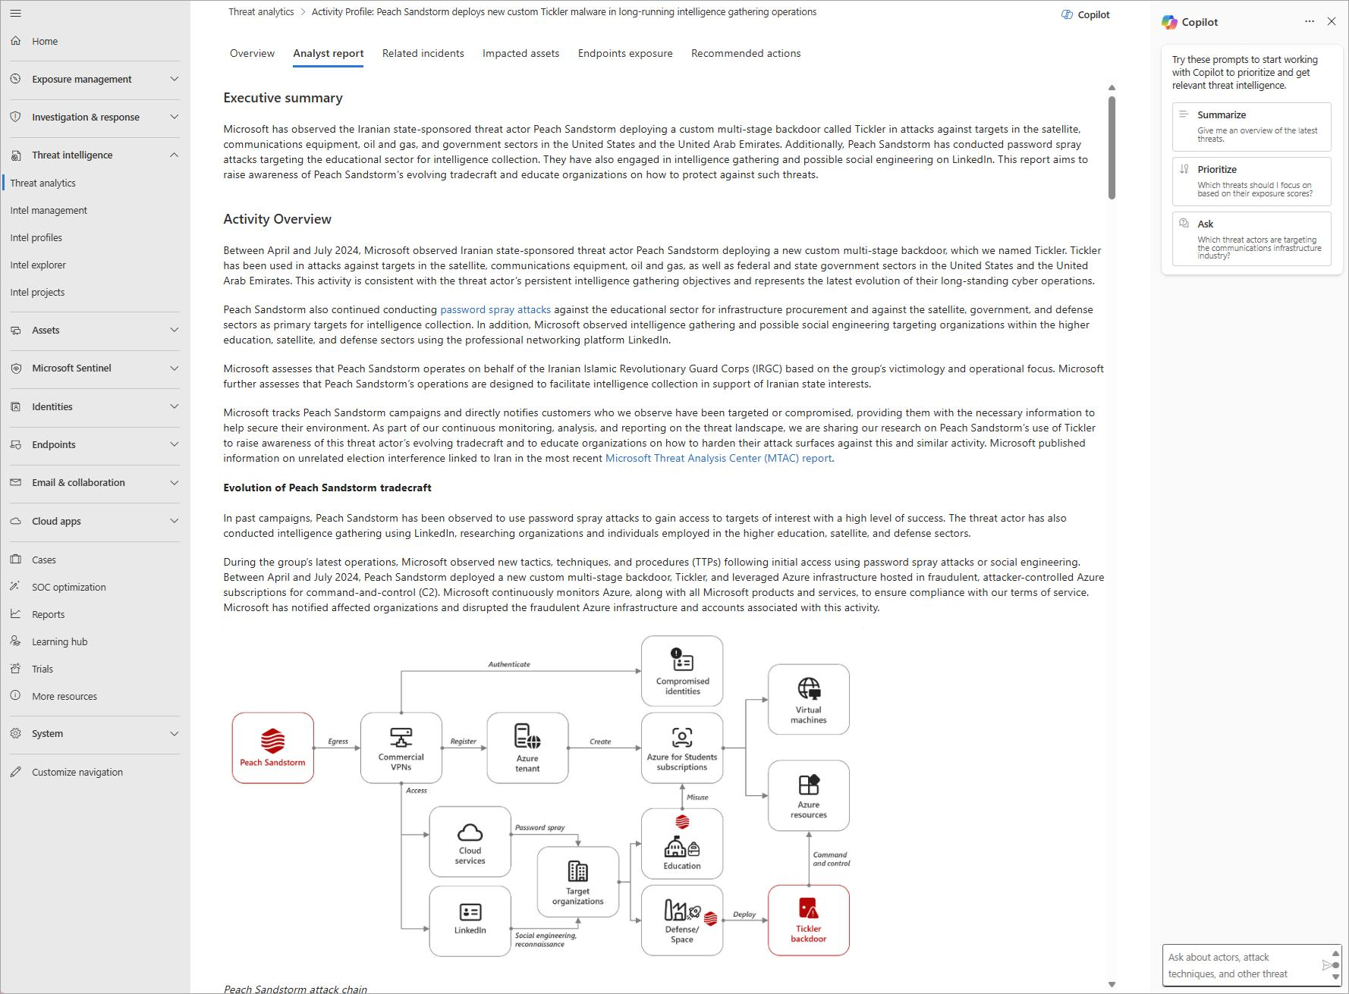
Figure 4:DustySky Multi-Stage Infection and Surveillance Workflow Used in Targeted Espionage Operations

Indicators of Compromise
Suspicious screenshot artifacts and archive staging.

Detection & Mitigation
Organizations should monitor endpoint telemetry, analyze outbound traffic anomalies, deploy EDR behavioral monitoring, and restrict execution of suspicious Office macros and unknown binaries.

Impact Analysis
Sensitive document theft and user monitoring.
DustySky
Field | Value
Campaign ID | S0062
Threat Actor / APT Group | Molerats
Campaign Name | DustySky Operations
Campaign Activity Period | 2015 – 2017
Software | DustySky
Target Country | Israel
Victim Country | Middle East Regions
Target Industry / Sector | Government & Research Institutions
Malware / Tool Used | .NET Surveillance Malware
IOC Type | File Hash
IOC Value | 7a8d9fxxxxxx
File Type / Hash Type | EXE / SHA256
IP Address | 185.xxx.xxx.xxx
IP Geolocation | Middle East

Field | Value
Domain / DNS | secure-update[.]org
Infrastructure Type | Malware Hosting Server
Attack Vector | Spear-Phishing Email
TTPs (MITRE ATT&CK) | T1113, T1005, T1027
Persistence Method | Scheduled Tasks
Privilege Escalation | User Execution
C2 Communication | HTTP Beaconing
Data Exfiltration Method | Archive Staging & Upload
Campaign Objective | Surveillance & Document Theft
Attribution Confidence | Moderate
Threat Severity | High
Detection Source | Sandboxing + EDR
Analyst Notes | Malware capable of screenshots and sensitive document collection

References
- MITRE ATT&CK Software Entry – DustySky
- MITRE ATT&CK Enterprise Matrix
- CISA Cybersecurity Advisories
- Palo Alto Unit 42 Threat Intelligence

ELMER
ELMER is a http backdoor associated with APT16. The malware primarily targets Windows environments. Proxy-aware Delphi malware built for stealthy command-and-control.

Technical Profile
- Threat Group Association: APT16
- Supported Platform: Windows
- Notable ATT&CK Technique: T1090 Proxy
- Operational Capability: Proxy-aware Delphi malware built for stealthy command-and-control.

Execution & Persistence
Delivery commonly occurred through phishing attachments, staged payloads, or malicious executables. Depending on the malware family, persistence mechanisms included registry autoruns, scheduled tasks, or stealthy loader execution.

Indicators of Compromise
Proxy-routed outbound sessions.

Detection & Mitigation
Organizations should monitor endpoint telemetry, analyze outbound traffic anomalies, deploy EDR behavioral monitoring, and restrict execution of suspicious Office macros and unknown binaries.

Impact Analysis
Covert communications bypassing monitoring.

References
- MITRE ATT&CK Software Entry – ELMER
- MITRE ATT&CK Enterprise Matrix
- CISA Cybersecurity Advisories
- Palo Alto Unit 42 Threat Intelligence

HDoor
HDoor is a backdoor associated with Naikon. The malware primarily targets Windows environments. Customized espionage malware supporting file transfer and credential collection.

Technical Profile
- Threat Group Association: Naikon
- Supported Platform: Windows
- Notable ATT&CK Technique: T1555 Credentials from Password Stores
- Operational Capability: Customized espionage malware supporting file transfer and credential collection.

Execution & Persistence
Delivery commonly occurred through phishing attachments, staged payloads, or malicious executables. Depending on the malware family, persistence mechanisms included registry autoruns, scheduled tasks, or stealthy loader execution.

Indicators of Compromise
Compressed credential archives.

Detection & Mitigation
Organizations should monitor endpoint telemetry, analyze outbound traffic anomalies, deploy EDR behavioral monitoring, and restrict execution of suspicious Office macros and unknown binaries.

Impact Analysis
Credential theft and intelligence collection.

References
- MITRE ATT&CK Software Entry – HDoor
- MITRE ATT&CK Enterprise Matrix
- CISA Cybersecurity Advisories
- Palo Alto Unit 42 Threat Intelligence

HTTPBrowser
HTTPBrowser is a backdoor associated with Chinese threat groups. The malware primarily targets Windows environments. Uses browser-like HTTP requests to blend into normal traffic.

Technical Profile
- Threat Group Association: Chinese threat groups
- Supported Platform: Windows
- Notable ATT&CK Technique: T1205 Traffic Signaling
- Operational Capability: Uses browser-like HTTP requests to blend into normal traffic.

Execution & Persistence
Delivery commonly occurred through phishing attachments, staged payloads, or malicious executables. Depending on the malware family, persistence mechanisms included registry autoruns, scheduled tasks, or stealthy loader execution.

Indicators of Compromise
Repeated browser-style beaconing.

Detection & Mitigation
Organizations should monitor endpoint telemetry, analyze outbound traffic anomalies, deploy EDR behavioral monitoring, and restrict execution of suspicious Office macros and unknown binaries.

Impact Analysis
Hidden C2 activity within normal browsing.

References
- MITRE ATT&CK Software Entry – HTTPBrowser
- MITRE ATT&CK Enterprise Matrix
- CISA Cybersecurity Advisories
- Palo Alto Unit 42 Threat Intelligence

httpclient
httpclient is a downloader associated with Putter Panda. The malware primarily targets Windows environments. Lightweight secondary-stage downloader used for payload retrieval.

Technical Profile
- Threat Group Association: Putter Panda
- Supported Platform: Windows
- Notable ATT&CK Technique: T1105 Ingress Tool Transfer
- Operational Capability: Lightweight secondary-stage downloader used for payload retrieval.

Execution & Persistence
Delivery commonly occurred through phishing attachments, staged payloads, or malicious executables. Depending on the malware family, persistence mechanisms included registry autoruns, scheduled tasks, or stealthy loader execution.

Indicators of Compromise
Temporary payload executables.

Detection & Mitigation
Organizations should monitor endpoint telemetry, analyze outbound traffic anomalies, deploy EDR behavioral monitoring, and restrict execution of suspicious Office macros and unknown binaries.

Impact Analysis
Malware staging and payload deployment.

References
- MITRE ATT&CK Software Entry – httpclient
- MITRE ATT&CK Enterprise Matrix
- CISA Cybersecurity Advisories
- Palo Alto Unit 42 Threat Intelligence

pngdowner
pngdowner is a downloader associated with Putter Panda. The malware primarily targets Windows environments. Simple download-and-execute utility with no known persistence.

Technical Profile
- Threat Group Association: Putter Panda
- Supported Platform: Windows
- Notable ATT&CK Technique: T1564.001 Hidden Files and Directories
- Operational Capability: Simple download-and-execute utility with no known persistence.

Execution & Persistence
Delivery commonly occurred through phishing attachments, staged payloads, or malicious executables. Depending on the malware family, persistence mechanisms included registry autoruns, scheduled tasks, or stealthy loader execution.

Indicators of Compromise
Hidden payload files disguised as images.

Detection & Mitigation
Organizations should monitor endpoint telemetry, analyze outbound traffic anomalies, deploy EDR behavioral monitoring, and restrict execution of suspicious Office macros and unknown binaries.

Impact Analysis
Secondary payload delivery support.

References
- MITRE ATT&CK Software Entry – pngdowner
- MITRE ATT&CK Enterprise Matrix
- CISA Cybersecurity Advisories
- Palo Alto Unit 42 Threat Intelligence

SHOTPUT
SHOTPUT is a backdoor associated with APT3. The malware primarily targets Windows environments. Backdoor supporting credential dumping and remote service abuse.

Technical Profile
- Threat Group Association: APT3
- Supported Platform: Windows
- Notable ATT&CK Technique: T1003 Credential Dumping
- Operational Capability: Backdoor supporting credential dumping and remote service abuse.

Execution & Persistence
Delivery commonly occurred through phishing attachments, staged payloads, or malicious executables. Depending on the malware family, persistence mechanisms included registry autoruns, scheduled tasks, or stealthy loader execution.

Indicators of Compromise
LSASS access attempts and remote service creation.
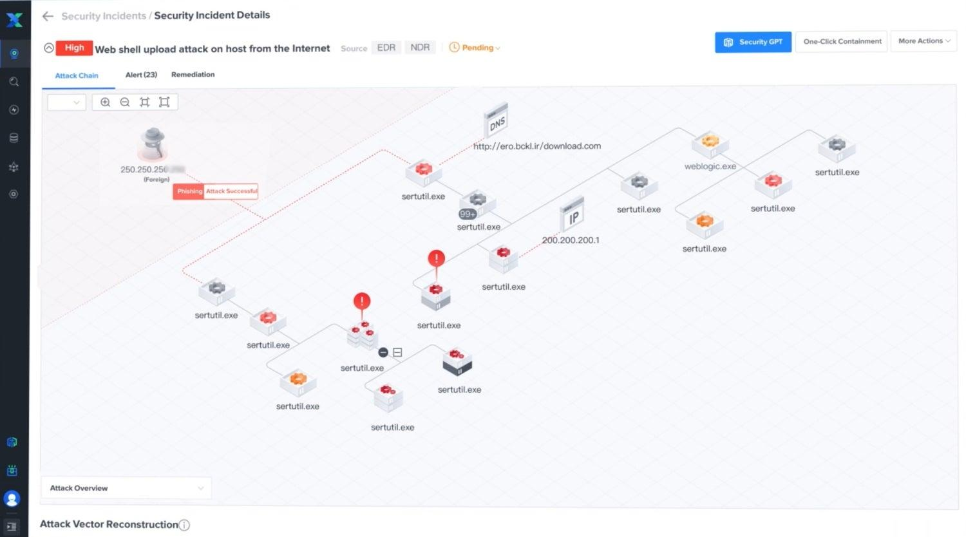
Figure 5:SHOTPUT Backdoor Intrusion Lifecycle and Post-Compromise Activity Associated with APT3

Detection & Mitigation
Organizations should monitor endpoint telemetry, analyze outbound traffic anomalies, deploy EDR behavioral monitoring, and restrict execution of suspicious Office macros and unknown binaries.

Impact Analysis
Credential compromise and lateral movement.
SHOTPUT
Field | Value
Campaign ID | S0063
Threat Actor / APT Group | APT3
Campaign Name | APT3 Espionage Campaign
Campaign Activity Period | 2014 – 2017
Software | SHOTPUT
Target Country | United States
Victim Country | Multiple Regions
Target Industry / Sector | Aerospace & Government
Malware / Tool Used | Credential Theft Backdoor
IOC Type | Registry Key
IOC Value | HKCU\Software\Microsoft\Windows\CurrentVersion\Run
File Type / Hash Type | Registry / Autorun
IP Address | 202.xxx.xxx.xxx
IP Geolocation | China

Field | Value
Domain / DNS | service-checker[.]com
Infrastructure Type | Remote Administration Infrastructure
Attack Vector | Spear-Phishing
TTPs (MITRE ATT&CK) | T1003, T1021
Persistence Method | Registry Persistence
Privilege Escalation | Credential Dumping
C2 Communication | HTTP/S Remote Sessions
Data Exfiltration Method | Remote File Exfiltration
Campaign Objective | Long-Term Espionage
Attribution Confidence | High
Threat Severity | Critical
Detection Source | SIEM + Threat Hunting
Analyst Notes | Associated with lateral movement and LSASS credential access

References
- MITRE ATT&CK Software Entry – SHOTPUT
- MITRE ATT&CK Enterprise Matrix
- CISA Cybersecurity Advisories
- Palo Alto Unit 42 Threat Intelligence

Sys10
Sys10 is a backdoor associated with Naikon. The malware primarily targets Windows environments. Espionage-focused malware targeting diplomatic and government entities.

Technical Profile
- Threat Group Association: Naikon
- Supported Platform: Windows
- Notable ATT&CK Technique: T1567 Exfiltration Over Web Service
- Operational Capability: Espionage-focused malware targeting diplomatic and government entities.

Execution & Persistence
Delivery commonly occurred through phishing attachments, staged payloads, or malicious executables. Depending on the malware family, persistence mechanisms included registry autoruns, scheduled tasks, or stealthy loader execution.

Indicators of Compromise
Archived data exfiltration activity.

Detection & Mitigation
Organizations should monitor endpoint telemetry, analyze outbound traffic anomalies, deploy EDR behavioral monitoring, and restrict execution of suspicious Office macros and unknown binaries.

Impact Analysis
Sensitive intelligence exfiltration.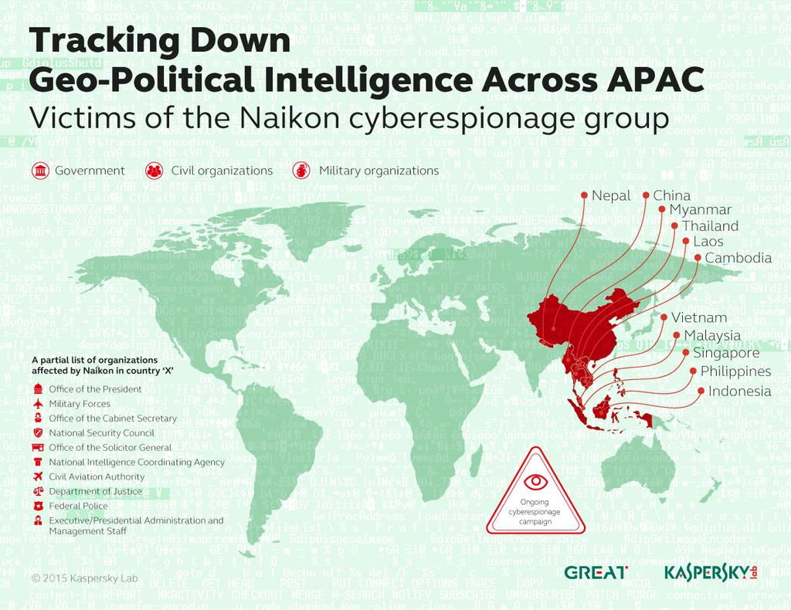
Figure 6: Naikon-Associated Espionage Activity and Sys10 Deployment Patterns Across Targeted Regions
Sys10
Field | Value
Campaign ID | S0060
Threat Actor / APT Group | Naikon
Campaign Name | Naikon Espionage Activity
Campaign Activity Period | 2013 – 2015
Software | Sys10
Target Country | Southeast Asia
Victim Country | Vietnam, Thailand, Philippines
Target Industry / Sector | Government & Military
Malware / Tool Used | Espionage Backdoor
IOC Type | Archive File
IOC Value | intel_data.rar
File Type / Hash Type | RAR Archive
IP Address | 45.xxx.xxx.xxx
IP Geolocation | China

Field | Value
Domain / DNS | asia-update[.]net
Infrastructure Type | Espionage Infrastructure
Attack Vector | Phishing Attachment
TTPs (MITRE ATT&CK) | T1567, T1036
Persistence Method | Startup Registry Keys
Privilege Escalation | DLL Hijacking
C2 Communication | HTTP-Based C2
Data Exfiltration Method | Archived Data Exfiltration
Campaign Objective | Intelligence Gathering
Attribution Confidence | Moderate
Threat Severity | High
Detection Source | Network Monitoring
Analyst Notes | Focused on diplomatic intelligence and regional surveillance

References
- MITRE ATT&CK Software Entry – Sys10
- MITRE ATT&CK Enterprise Matrix
- CISA Cybersecurity Advisories
- Palo Alto Unit 42 Threat Intelligence

Conclusion
The Operation Honeybee campaign demonstrates how modern espionage-focused threat actors combine social engineering, malware deployment, covert persistence, and command-and-control infrastructure to support long-term intelligence collection objectives. The malware families analyzed throughout this report illustrate the importance of ATT&CK-based defensive strategies and proactive threat hunting.

